http://www.chistvincent.com/Email_Signatures/infirmary_files/chi_logo.jpg

***“Achieving Excellence in Nursing Practice”***

**American Association of Colleges of Nursing (Vizient/AACN) Nurse Residency Program™. Program (RNRP)**

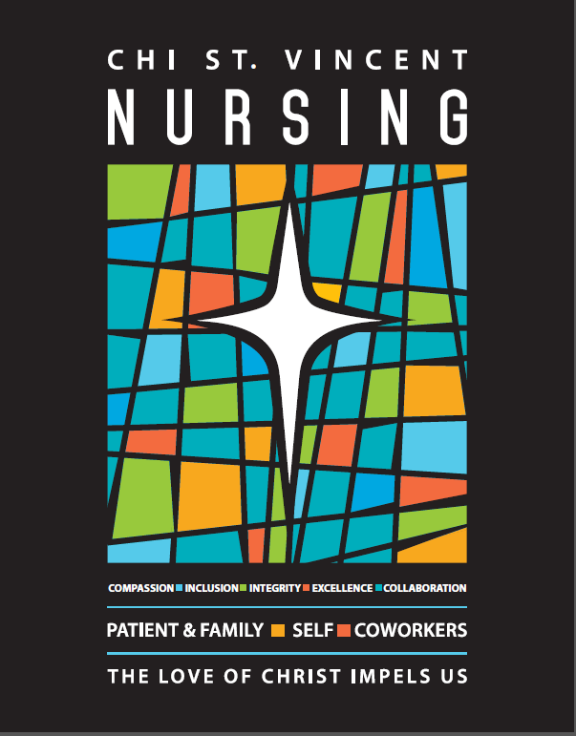



**RN Residency Program**

Introduction

The RN Residency Program (RNRP) at CHI St. Vincent prepares new graduates in nursing to enter practice in the acute care environment. For over 125 years, CHI St Vincent has been dedicated to preparing new nurses for entry into practice. Today, that commitment is stronger than ever, with an excellent program for new graduates interested in a nursing career that is built on a firm foundation. By maintaining a high level of knowledge and skill among all who serve our patients, we provide high quality nursing care.

**Vizient/AACN Nursing Residency Program™**

Trusted by more than 450 hospitals and health systems nationwide, and adopted as the state model for Hawaii, Maryland, and Pennsylvania, the Vizient/AACN Nurse Residency ProgramTM (NRP) focuses on new graduate nurses as they enter practice resulting in a retention rate of 92.7%vs the national average of 82.5%.

**About The Vizient/AACN Nurse Residency Program™**

The Vizient/AACN Nurse Residency Program™ operates at more than 350 healthcare organizations. Since its establishment in 2002, more than 72,000 new graduate nurses have participated in the program. Notably, The Institute of Medicine recently published *The Future of Nursing* report identifying actionable measures that will transform the nursing profession – specifically highlighting the importance of nurse residency programs for nurses entering the transition-to-practice. To-date, the Vizient/AACN Nurse Residency Program has reduced turnover rates among first-year nurses achieving an average retention rate of 95%, exceeding the national average of 75%. For more information, visit The Vizient/AACN Nurse Residency Program™.

**What is the Nurse Residency Program?**

The Nurse Residency Program (NRP) supports new nurse graduates as they transition into their first professional role as caregivers. Built on evidence-based curriculum developed by experts from academic medical centers and nursing schools across the country, the program focuses on three critical areas: leadership, patient outcomes, and the professional role. This extensive one-year program features a series of learning and hands-on work experience that develops clinical leadership skills necessary to become a successful member of the health care team.

The program is a formal, structured program for post-baccalaureate and associate degree nurses and is part of the Vizient/AACN Nurse Residency Program model. Each resident will participate in monthly education experience that may include classroom, simulation or other types of learning and is assigned a preceptor who guides the hands-on clinical experience.

Program Objective and Emphasis

The Nurse Residency Program emphasizes critical thinking skills, incorporates research-based practice, patient safety, and professional development.

*The program prepares nursing graduates to:*

* Care for patients with increasing levels of acuity and complexity in the hospital setting
* Develop clinical nursing leadership at point of care
* Improve patient safety and quality of care
* Foster critical thinking skills
* Bring evidence-based practice to the bedside
* Strengthen the commitment to the profession of nursing and develop individual career goals
* Facilitate clinical and leadership skills necessary to be a successful member of the health care team

**Clinical Placement**

Applicants to the RN Residency Program are hired for **one** CHI St. Vincent location:

1. CHI St. Vincent Infirmary
2. CHI St. Vincent North
3. CHI St. Vincent Morrilton
4. CHI St. Vincent Hot Springs in Hot Springs, Arkansas

During the application process, applicants have an opportunity to indicate their unit and shift preference, if known, or their track preference (Hot Springs ONLY).

**CHI St. Vincent Co-workers**

1. CHI St. Vincent co-workers must meet the RN Residency Program requirements listed above.
2. Current CHI St. Vincent co-workers may not be eligible for acceptance if they have received a final written warning for any reason during the previous 12 months.

**Application Process:**

**Applications Open: February 1st for May Graduates**

**September 1st for December Graduates**

**Application to the RN Residency Program is EASY:**

1. Complete a CHI St. Vincent Employment Application for an “RN Residency” position at [www.CHIstvincent.com](http://www.CHIstvincent.com) (Note this position is only posted on the website during the open application period)

**Required Documents **

1. Upload, along with your application submission:

* A Professional Resume
* Cover Letter detailing the area or Specialty of interest
* Unofficial Transcript with cumulative hours of credit and cumulative GPA. (current)

*Please note: Due to a high demand for Critical Care and ED placement (at Infirmary), those with a GPA of 3.0 or better and an “A” or “B” passing grade on the first attempt in the advanced classes related to critical care will be given preference in placement.*

RN Residency Program Contacts: Sarah Beeler MNSc, RN

[SNBeeler@stvincenthealth.com](mailto:SNBeeler@stvincenthealth.com)

501-552-3674

Nisa Trenthem MNSc, RN, NE-BC

[NATrenthem@stvincenthealth.com](mailto:NATrenthem@stvincenthealth.com)

Director-Nursing Excellence

Employment Offer

A Human Resources representative extends employment offers for positions in the RNRP and discusses pre-hire requirements.

Licensure Information

Selected candidates should assure that all required paperwork for licensure is submitted to the Arkansas State Board of Nursing immediately upon graduation from the nursing program to obtain Arkansas licensure. Temporary or permanent Arkansas Licensure is required within two weeks of start date for continuance in the RNRP. NCLEX should be scheduled as soon as possible to obtain permanent Arkansas licensure.